**Sample Written examination # 4 – By Jack Graffeo**

**November 2023**

**Reading time: 15 mins**

**Writing time: 2 hours**

**QUESTION AND ANSWER BOOK**

**Structure of the exam**

|  |  |  |  |  |  |
| --- | --- | --- | --- | --- | --- |
|  | *Section* | *Number of questions* | *Number of questions to be answered* | *Number of marks* |  |
|  | A | 10 | 10 | 60 |  |
|  | B | 4 | 1 | 20 |  |
|  |  |  |  | Total 80 |  |

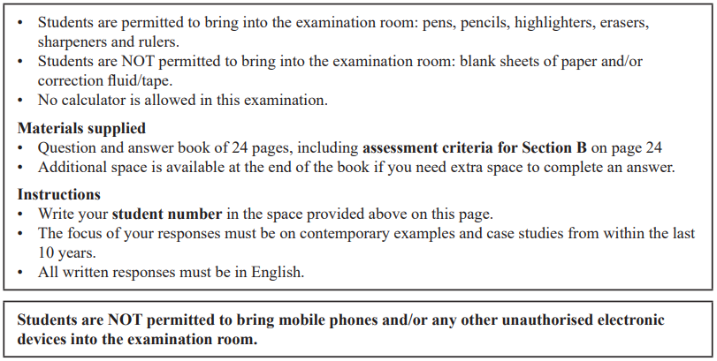

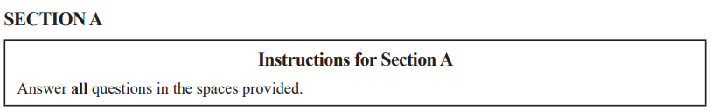

**Question 1** (3 marks)

Describe one role of a legal non-state actor.

|  |
| --- |
|  |
|  |
|  |
|  |
|  |
|  |
|  |
|  |
|  |

**Question 2** (4 marks)

Explain how one Transnational corporation (TNC) can be considered a driver of progress, skills or innovation.

|  |
| --- |
|  |
|  |
|  |
|  |
|  |
|  |
|  |
|  |
|  |
|  |
|  |
|  |

**Question 3** (6 marks)

Assess the extent to which the International Monetary Fund (IMF) effectively facilitates global governance.

|  |
| --- |
|  |
|  |
|  |
|  |
|  |
|  |
|  |
|  |
|  |
|  |
|  |
|  |
|  |
|  |
|  |
|  |
|  |
|  |

**Question 4 (17 marks)**

One of the following Asia-Pacific states must be used as the focus of all responses to Question 4: Australia, China, Indonesia, Japan or the United States of America.

Selected Asia-Pacific state: ____________________________________________________

1. Describe how idealism has influenced this Asia-Pacific state’s use of cultural power. (3 marks)

|  |
| --- |
|  |
|  |
|  |
|  |
|  |
|  |
|  |
|  |
|  |

1. Discuss two differing interpretations of this Asia-Pacific state’s pursuit of regional relationships. (6 marks)

|  |
| --- |
|  |
|  |
|  |
|  |
|  |
|  |
|  |
|  |
|  |
|  |
|  |
|  |
|  |
|  |
|  |
|  |
|  |
|  |

1. Compare the extent to which this Asia-Pacific state has successfully achieved two of its national interests. (8 marks)

|  |
| --- |
|  |
|  |
|  |
|  |
|  |
|  |
|  |
|  |
|  |
|  |
|  |
|  |
|  |
|  |
|  |
|  |
|  |
|  |
|  |
|  |
|  |
|  |
|  |
|  |

**Question 5** (4 marks)

From the list below, select one ethical issue that you have studied this year:

**You must respond to the same ethical issue in Question 5 and 6.**

• human rights

• people movement

• development

• arms control

Ethical issue: _______________________________________________________________

Explain one limitation to the effectiveness of one international law in addressing this ethical issue.

|  |
| --- |
|  |
|  |
|  |
|  |
|  |
|  |
|  |
|  |
|  |
|  |
|  |
|  |

**Question 6** (5 marks)

Using an ethical debate, discuss how this ethical issue can challenge the national interests of a state.

**You must respond to the same ethical issue as Question 5.**

|  |
| --- |
|  |
|  |
|  |
|  |
|  |
|  |
|  |
|  |
|  |
|  |
|  |
|  |
|  |
|  |
|  |

**Question 7** (6 marks)

Select another ethical issue that you have studied this year. The ethical issue selected must be **different** from the one selected in Question 5 and 6.

Ethical issue ________________________________________________________________

Evaluate the effectiveness of one global actor’s response to this ethical issue.

|  |
| --- |
|  |
|  |
|  |
|  |
|  |
|  |
|  |
|  |
|  |
|  |
|  |
|  |
|  |
|  |
|  |
|  |
|  |
|  |
|  |

**Question 8** (4 marks)

From the list below, select one global crisis that you have studied this year:

**You must respond to the same global crisis in Question 8 and 9.**

• climate change

• armed conflict

• terrorism

• economic instability

Global crisis: _______________________________________________________________

Explain one way globalisation has supported the effective resolution of this global crisis.

|  |
| --- |
|  |
|  |
|  |
|  |
|  |
|  |
|  |
|  |
|  |
|  |
|  |
|  |

**Question 9** (5 marks)

Analyse the impact of one instance of crisis diplomacy in supporting an effective response to this global crisis.

**You must respond to the same global crisis as Question 8.**

|  |
| --- |
|  |
|  |
|  |
|  |
|  |
|  |
|  |
|  |
|  |
|  |
|  |
|  |
|  |
|  |
|  |

**Question 10** (6 marks)

Select another global crisis that you have studied this year. The global crisis selected must be **different** from the one selected in Question 8 and 9.

Global crisis ________________________________________________________________

Compare the effectiveness of two global actor’s responses to this global crisis.

|  |
| --- |
|  |
|  |
|  |
|  |
|  |
|  |
|  |
|  |
|  |
|  |
|  |
|  |
|  |
|  |
|  |
|  |
|  |
|  |

**SECTION B**

Write an essay on one of the following questions in the space provided.

Your response will be assessed according to the assessment criteria set out on the back page.

**Question 1** (20 marks)

‘Contested and changing state borders present the most significant challenge to state sovereignty.’ Discuss with reference to the different challenges facing state sovereignty.

**OR**

**Question 2** (20 marks)

Don’t do this question, unless you want to do bad on this exam.

**OR**

**Question 3** (20 marks)

To what extent do international laws assist with the resolution of two ethical issues?

**OR**

**Question 4** (20 marks)

Assess the effectiveness of international cooperation in supporting the resolution of two global crises.



|  |
| --- |
|  |
|  |
|  |
|  |
|  |
|  |
|  |
|  |
|  |
|  |
|  |
|  |
|  |
|  |
|  |
|  |
|  |
|  |
|  |
|  |
|  |
|  |
|  |
|  |
|  |
|  |
|  |
|  |
|  |
|  |
|  |
|  |
|  |
|  |
|  |
|  |
|  |
|  |
|  |
|  |
|  |
|  |
|  |
|  |
|  |
|  |
|  |
|  |
|  |
|  |
|  |
|  |
|  |
|  |
|  |
|  |
|  |
|  |
|  |
|  |
|  |
|  |
|  |
|  |
|  |
|  |
|  |
|  |
|  |
|  |
|  |
|  |
|  |
|  |
|  |
|  |
|  |
|  |
|  |
|  |
|  |
|  |
|  |
|  |
|  |
|  |
|  |
|  |
|  |
|  |
|  |
|  |
|  |
|  |
|  |
|  |
|  |
|  |
|  |
|  |
|  |
|  |
|  |
|  |
|  |
|  |
|  |
|  |
|  |
|  |
|  |
|  |
|  |
|  |
|  |
|  |
|  |
|  |
|  |
|  |
|  |
|  |
|  |
|  |
|  |
|  |
|  |
|  |
|  |
|  |
|  |
|  |
|  |
|  |
|  |
|  |
|  |
|  |
|  |
|  |
|  |
|  |
|  |
|  |
|  |
|  |
|  |
|  |
|  |
|  |
|  |
|  |
|  |
|  |
|  |
|  |
|  |
|  |
|  |
|  |

**END OF SECTION B**

**Extra space for responses.**

**Clearly number all responses in this space.**

|  |
| --- |
|  |
|  |
|  |
|  |
|  |
|  |
|  |
|  |
|  |
|  |
|  |
|  |
|  |
|  |
|  |
|  |
|  |
|  |
|  |
|  |
|  |
|  |
|  |
|  |
|  |
|  |
|  |
|  |
|  |
|  |
|  |
|  |
|  |
|  |
|  |
|  |
|  |
|  |
|  |
|  |
|  |
|  |
|  |
|  |
|  |
|  |
|  |
|  |
|  |
|  |

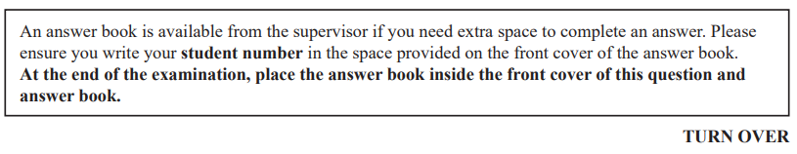

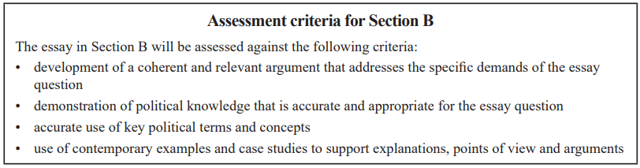

**END OF QUESTION AND ANSWER BOOK**

